**Thermodynamic analysis of the pathway for ethanol production from cellobiose in *Clostridium thermocellum***

Satyakam Dash1, 5, Daniel G. Olson2, 5, Siu Hung Joshua Chan3, 5, Daniel Amador-Noguez4, 5, Lee R. Lynd2, 5 and **Costas D. Maranas**1, 5*

1Department of Chemical Engineering, The Pennsylvania State University, University Park, University Park, Pennsylvania, USA

2Thayer School of Engineering at Dartmouth College, Hanover, New Hampshire, USA

3Department of Chemical and Biological Engineering, Colorado State University, Fort Collins, Colorado, USA

4Department of Bacteriology, University of Wisconsin, Madison, Wisconsin, USA

5Center for Bioenergy Innovation, Oak Ridge National Laboratory, Oak Ridge, TN 37830, USA

E-mail: Satyakam Dash: satyakam@psu.edu, Daniel G. Olson: Daniel.G.Olson@dartmouth.edu, Siu Hung Joshua Chan: joshua.chan@colostate.edu, Daniel Amador-Noguez : amadornoguez@wisc.edu, Lee R. Lynd : lee.r.lynd@dartmouth.edu, and Costas D. Maranas: [costas@psu.edu](mailto:costas@psu.edu)

*Corresponding author:

Costas D. Maranas (costas@psu.edu)

The Pennsylvania State University

126 Land and Water Research Building

University Park, PA 16802

Phone: 814-863-9958

**Abstract**

*Clostridium thermocellum* is a candidate for consolidated bioprocessing by carrying out both cellulose solubilization and fermentation. However, despite significant efforts the maximum ethanol titer achieved to date remains below industrially required targets. Several studies have analyzed the impact of increasing ethanol concentration on *C. thermocellum*’s membrane properties, cofactor pool ratios, and altered enzyme regulation. In this study, we explore the extent to which thermodynamic equilibrium limits maximum ethanol titer. We used the max-min driving force (MDF) algorithm (Noor et al., 2014) to identify the range of allowable metabolite concentrations that maintain a negative free energy change for all reaction steps in the pathway from cellobiose to ethanol. To this end, we used a time-series metabolite concentration dataset to flag five reactions (phosphofructokinase (PFK), fructose bisphosphate aldolase (FBA), glyceraldehyde-3-phosphate dehydrogenase (GAPDH), aldehyde dehydrogenase (ALDH) and alcohol dehydrogenase (ADH)) which become thermodynamic bottlenecks under high external ethanol concentrations. Thermodynamic analysis was also deployed in a prospective mode to evaluate genetic interventions which can improve pathway thermodynamics by generating minimal set of reactions or elementary flux modes (EFMs) which possess unique genetic variations while ensuring mass and redox balance with ethanol production. MDF evaluation of all generated (336) EFMs indicated that, i) pyruvate phosphate dikinase (PPDK) has a higher pathway MDF than the malate shunt alternative due to limiting CO2 concentrations under physiological conditions, and ii) NADPH-dependent glyceraldehyde-3-phosphate dehydrogenase (GAPN) can alleviate thermodynamic bottlenecks at high ethanol concentrations due to cofactor modification and reduction in ATP generation. The combination of ATP linked phosphofructokinase (PFK-ATP) and NADPH linked alcohol dehydrogenase (ADH-NADPH) with NADPH linked aldehyde dehydrogenase (ALDH-NADPH) or ferredoxin: NADP+ oxidoreductase (NADPH-FNOR) emerges as the best intervention strategy for ethanol production that balances MDF improvements with ATP generation, and appears to functionally reproduce the pathway employed by the ethanologen *Thermoanaerobacterium saccharolyticum*. Expanding the list of measured intracellular metabolites and improving the quantification accuracy of measurements was found to improve the fidelity of pathway thermodynamics analysis in *C. thermocellum*. This study demonstrates even before addressing an organism’s enzyme kinetics and allosteric regulations, pathway thermodynamics can flag pathway bottlenecks and identify testable strategies for enhancing pathway thermodynamic feasibility and function.

**Highlights**

* Thermodynamic analysis of time-varying metabolomic data showed bottlenecks distributed across five reactions (phosphofructokinase (PFK), fructose bisphosphate aldolase (FBA), glyceraldehyde-3-phosphate dehydrogenase (GAPDH), aldehyde dehydrogenase (ALDH) and alcohol dehydrogenase (ADH)) under high external ethanol concentrations.
* Pyruvate phosphate dikinase reaction is more thermodynamically favorable than malate shunt in *C. thermocellum.*
* NADPH-dependent glyceraldehyde-3-phosphate dehydrogenase can provide larger thermodynamic driving force at the cost of ATP generation.
* The combination of ATP linked phosphofructokinase (PFK-ATP) and NADPH linked alcohol dehydrogenase (ADH-NADPH) with NADPH linked aldehyde dehydrogenase (ALDH-NADPH) or ferredoxin: NADP+ oxidoreductase (NADPH-FNOR) qualify as the best intervention strategy for ethanol production in *C. thermocellum* with a high driving force as well as ATP generation.

**Keywords:** Thermodynamic analysis;*Clostridium thermocellum*; ethanol inhibition; elementary flux modes; genetic interventions

# Introduction

Biofuels have emerged as a promising alternative for reducing our dependence on fossil fuels (Lynd, 2017; Lynd et al., 2017). One of the most industrially relevant biofuel production strategy involves microbial fermentation of cellulose to alcohols (Lynd et al., 2002). *Clostridium thermocellum* is a promising candidate as it can both solubilize cellulose and produce ethanol. However, in native *C. thermocellum,* growth is inhibited by ethanol titers lower than the organism’s tolerance limit (referred to as “titer gap”) preventing its wide-spread industrial adoption (Olson et al., 2012). Several studies have delved into the ethanol inhibition problem by analyzing ethanol-adapted *C. thermocellum* strains with respect to genetic interventions, membrane composition changes, cofactor pool ratio variations, and feedback regulations which affect enzyme kinetics (Brown et al., 2011; Demain et al., 2005; Hon et al., 2017; Olson et al., 2017; Olson et al., 2015; Shao et al., 2011; Thompson and Trinh, 2017; Tian et al., 2017a). An alternate cause for the low ethanol titer problem not explored previously involves identifying and modifying reaction steps that are limited by thermodynamic equilibrium.

Thermodynamic constraints have previously been integrated in computational modeling techniques such as flux balance calculations to determine possible reaction directionality and predict feasible metabolite concentration ranges (Ataman and Hatzimanikatis, 2015). Kinetic parameterization procedures often use thermodynamic imperatives (i.e., negative free energy) to reduce the search space of feasible kinetic parameters and restrict reaction reversibility (Dash et al., 2017). Thermodynamic analysis can be extended beyond single reactions to entire pathways (Hadicke et al., 2018). The thermodynamic feasibility of an entire multi-step linear pathway can be evaluated by identifying the reaction step with the smallest (though still negative) change in Gibbs free energy (ΔrG′). The smallest value of -ΔrG′ (thus a positive quantity) is referred to as the minimum driving force denoting the thermodynamic bottleneck of the pathway. The max-min driving force (MDF) formulation (Noor et al., 2014) identifies the largest minimum driving force achievable in the pathway by modulating the metabolite concentrations within physiological limits (Noor et al., 2014). The variability in metabolite concentrations under the MDF can also be used to assess the impact of metabolite pool accumulations and/or depletions on pathway feasibility (Noor et al., 2014). Thermodynamic bottleneck analysis has been applied to study the cause of growth cessation in *C. thermocellum* under high substrate loading conditions, suggesting that fermentation is inhibited at the pyruvate to acetyl-CoA conversion step due to accumulation of hydrogen (which inhibits the pyruvate formate oxidoreductase (PFOR) reaction via increased reduced ferredoxin levels) and formate (which inhibits the pyruvate formate lyase (PFL) reaction) (Thompson and Trinh, 2017). Thermodynamic analysis of multiple pathways can be explored seamlessly using the concept of elementary flux modes (EFMs) which can be defined as a redox and energy balanced (Wlaschin et al., 2006) minimal set of reactions that under steady-state conditions allows for the generation of a set of products from a given set of reactants (Trinh et al., 2009). EFMs have also found numerous application in metabolic engineering such as identifying genetic interventions (Thompson et al., 2015), and elucidating pathway costs which lead to overflow metabolism (Noor et al., 2014). In this study, we explore the impact of increasing ethanol concentration on the thermodynamic landscape of C. thermocellum’s native metabolism and explore genetic interventions characterized by unique EFMs which can resolve ethanol inhibition.

# Materials and methods

## Metabolite quantification

Metabolite and fermentation data is chosen from one of the datasets presented in Tian et al. (Tian et al., 2017b). The datasets different in terms of biomass levels and ethanol concertation values. Combining the datasets led to a significant increase in metabolite pool uncertainty (supplementary **) to ensure thermodynamic feasibility of the pathways for no ethanol conditions. Thus, we chose the dataset with higher ATP charge value signifying arrested metabolism. The datasets are described here briefly for reference. A single 200 ml culture was grown to an OD600 of 0.1, and then split in half. Starting at 2 hours (post-split), ethanol was added to one culture at a rate of about 9 g/L/h. No ethanol was added to the other culture. At three timepoints (T=2.0h, 3.8h and 5.9h), each culture was sampled twice for intracellular metabolites using previously described protocols (Beri et al., 2016; Rabinowitz and Kimball, 2007; Tian et al., 2017b), and once for extracellular metabolites (Supplementary file 1). The raw data was re-processed with El-Maven 0.5.0 and quantified using external standards. Since the response was not linear over the full range of the standards (0.1 µM to 100 µM), quantification was performed by piecewise linear interpolation (Supplementary file 2). Based on four measurements of our standard curves, we used an uncertainty factor of 20% during our simulations. One significant change that we observed from the absolute quantification is that the energy charge (ATP or GTP, calculated using Equation (1)) values which had previously been calculated to be around 0.9, were actually much lower, in the range of 0 to 0.15, which is much lower than expected (Rabinowitz and Kimball, 2007). Since we were not confident of the energy cofactor measurements, these metabolites were excluded from analysis.

(1)

In addition, NADH was not observed for the no ethanol control cultures. Since NADH and NAD+ form a cofactor pair, both metabolites were excluded from analysis. Metabolites are typically diluted during the quenching and extraction process, to determine the intracellular concentration of metabolites, thus the measured concentration was adjusted using Equation (2).

(2)

The intracellular volume is assumed to be 3.9 µL for 1 ml of a culture at an OD600 density of 1 (Volkmer and Heinemann, 2011). The concentration factor was calculated separately for each extraction, based on the measured OD600 and sample volume. The target cell density (OD600 x ml) was 2.0, but varied from 1.6 to 2.1 (Supplementary file 3). The metabolite concentrations obtained above were renormalized using absolute concentration measurements for cells grown to an OD600 value of 0.4 (Table 1). The absolute concentration value for each timepoint was obtained by taking an average across the replicates. The metabolite concentration bounds for all the timepoints inclusive of the 20% error can be found in supplementary file XX.

**Table 1.** Intracellular concentrations of WT *C. thermocellum* used as reference in this study.

|  |  |
| --- | --- |
| Metabolite | Concentrations (mM) |
| g6p | 8.19 |
| f6p | 1.49 |
| fdp | 1.50 |
| mal-l | 37.81 |
| dhap | 1.27 |
| g3p | 0.10 |
| 3pg | 1.35 |
| pep | 0.69 |
| coa | 0.02 |

## Assessing the thermodynamic feasibility of a pathway

The thermodynamic feasibility of a given pathway is assessed using the max-min driving force formulation (Noor et al., 2014). The MDF formulation identifies a set of metabolite concentrations that ensure the lowest free energy changes for all the reactions in a pathway. The MDF problem minimizes the maximum of a pathway by optimizing over the concentrations of all metabolites in the pathway. The formulation is given by:

|  |  |  |
| --- | --- | --- |
|  | (-MDF) | (3) |
|  |  | (4) |
|  |  | (5) |
|  |  |  |

where *I*is the set of all metabolites and *J*is the set of all reactions in a given pathway, is the concentration of metabolite , is the gas constant, is the temperature and the matrix refers to the stoichiometric matrix of the pathway with . Constraint (4) relates the Gibbs free energy of reaction () with the standard Gibbs free energy of reaction () and the mass action ratio. The pathway with a positive objective function (i.e. negative MDF) indicates that it is thermodynamically infeasible within the given physiological concentration ranges. For performing the MDF analysis, maximum and minimum metabolite concentration bounds were established using the data from Tian et al which represents intracellular metabolites collected from wild type (WT) *C. thermocellum* growing with and without (control) the presence of added ethanol for two replicates each at three different time points. Several cofactors were excluded from analysis due to measurement problems. To avoid biasing the results by including only a few measured cofactors, we opted to ignore measured values for all cofactors (ATP, ADP, AMP, GTP, GDP, NAD+. NADH, NADP+ and NADPH). Concentration ranges for energy cofactors (ATP/ADP, ATP/AMP, GTP/GDP) were set to allow ratios greater than 10:1 and redox cofactors (NADH/NAD+, NADPH/NADP+, Fd(red)/Fd(ox)) to vary between 1:100 and 100:1. Although Noor et al (Noor et al., 2014) fixed the ratios of several cofactor pairs, we have relaxed these constraints based on other clostridia when substrate is not limiting (Bennett and San, 2009; Meyer and Papoutsakis, 1989; Milo et al., 2010; Noor et al., 2014), since the values have not been experimentally determined for *C. thermocellum*. For non-measured metabolites, Noor et al (Noor et al., 2014) proposed a range of 1 µM to 10 mM, based largely on the work of Bennet et al (Bennett and San, 2009). Based on our measurements, we decided to keep the default lower concentration at 1 µM, but raise the default upper concentration from 10 mM to 20 mM. Default bounds for each metabolite is described in Supplementary file 6. The pH of the system was set to 7.0 and the ionic strength set to 0.1 M. The MDF problem is solved using Gurobi Optimizer v6.5.1 solver and Python script modified from the Equilibrator-API Python package (Noor et al., 2013).

## EFM evaluation

We implement the algorithm to generate k-shortest EFM of a network to systematically evaluate all the EFMs associated with our network (de Figueiredo et al., 2009). The formulation which largely matches the one of OptStrain (Pharkya et al., 2004) is given by:

|  |  |  |
| --- | --- | --- |
|  |  | (6) |
|  |  | (7) |
|  |  | (8) |
|  |  | (9) |
|  |  | (10) |
|  |  | (11) |
|  |  | (12) |

where *I* is the set of all metabolites and *J* is the set of all reactions, is the set of exchange reactions, the rate of reactions is represented by and represents the stoichiometric coefficient of the metabolite *i* in reaction *j*, *K* represents the set of previously found solutions and indicates the optimal value of the binary variable in the *kth* solution . The binary variable (constraint 10) assumes a value of 1 if the reaction *j* is included in the EFM and 0 otherwise. The smallest EFM is found by minimizing the sum of all these binary variables as shown by constraint 6. Steady state of the network is ensured by enforcing no net accumulation or consumption of metabolites as shown by constraint 7. The network is decomposed to ensure that all reaction fluxes are positive (constraint 11) and the binary variable was linked to reaction rates by constraint 8. The binary variables corresponding to exchange reactions () are fixed by constraint 9 to ensure that all EFMs consume the substrate (cellobiose) and generate the product (ethanol). Reaction pairs which should not appear in the same EFM can be excluded by adding an exclusivity constraint (i.e., only one reaction from the pair is active in any given solution) on their corresponding binary variables. We finally use integer cuts (constraint 12) to generate all possible EFMs associated with the network. The ATP generated by any given EFM is calculated by adding the fluxes of the two ATP hydrolysis reactions in the models (Table 2).

Table 2: List of all possible reactions in any given EFM.

|  |  |
| --- | --- |
| **Reaction Name** | **Equation** |
| ATPase1 | h2o + ATP <=> ADP + pi |
| CBP | pi + cellb <=> glc-d + g1p |
| BGL | cellb + h2o <=>2 glc-d |
| GLK-GTP | glc-d + GTP <=> g6p + GDP |
| GLK-ATP | glc-d + ATP <=> g6p + ADP |
| PGMT | g1p <=> g6p |
| PGI | g6p <=> f6p |
| PFK-PPi | ppi + f6p <=> pi + fdp + h |
| PFK-ATP | ATP + f6p <=> ADP + fdp |
| FBA | fdp <=> dhap + g3p |
| TPI | dhap <=> g3p |
| GAPDH | pi + NAD+ + g3p <=> NADH + 13dpg |
| GAPN | g3p + NADP+ + h2o <=> 3pg + NADPH |
| PGK-ATP | ADP + 13dpg <=> ATP + 3pg |
| PGK-GTP | GDP + 13dpg <=> GTP + 3pg |
| PGM | 3pg <=> 2pg |
| ENO | 2pg <=> pep + h2o |
| PYK | ADP + pep <=> pyr + ATP |
| PPDK | AMP + ppi + pep <=> ATP + pi + pyr + h |
| PEPCK | GDP + co2 + pep <=> GTP + oaa |
| MDH | NADH + oaa <=> NAD+ + mal-l |
| ME | NADP+ + mal-l <=> NADPH + co2 + pyr |
| PFOR | coa + 2 FDXOX + pyr <=> h + accoa + 2 FDXRD + co2 |
| RNF_ATPase | 2 FDXRD + 1 NAD++ 0.25 ADP + 0.25 pi <=> 2 FDXOX + 1 NADH + 0.25 ATP + 0.25 h2o |
| RNF_PPiase | 2 FDXRD + 1 NAD++ 1 h + 1 pi <=> 2 FDXOX + 1 NADH + 0.5 ppi + 0.5 h2o |
| NFN | 2 FDXRD + NADH + 2 NADP+ <=> 2 FDXOX + NAD+ + 2 NADPH |
| PDC | pyr <=> acald + co2 |
| ALDH-NADH | NADH + accoa <=> NAD+ + coa + acald |
| ALDH-NADPH | NADPH + accoa <=> NADP+ + coa + acald |
| ADH-NADH | acald + NADH <=> etoh + NAD+ |
| ADH-NADPH | acald + NADPH <=> etoh + NADP+ |
| Bifur_Hyd | 2 FDXRD + NADH + 2 h <=>NAD+ + 2 h2 + 2 FDXOX |
| NDK | GTP + ADP <=> ATP + GDP |
| Gly-cyc | ATP + pi <=> ADP + ppi |
| NADPH-FNOR | 2 FDXRD + NADP+ <=> 2 FDXOX + NADPH |
| NADH-FNOR | 2 FDXRD + NAD+ <=> 2 FDXOX + NADH |
| ATPase2 | ATP + h2o <=> AMP + ppi |

# Results and discussion

We studied the impact of increasing ethanol concentration on *C. thermocellum*’s metabolism using MDF analysis. We restricted our analysis to the glycolytic pathway by which cellobiose is converted to ethanol, including cofactor regeneration (Figure 1). Using thermodynamic feasibility of time varying metabolite concentrations for *C. thermocellum* grown with and without external ethanol addition (see Supplementary file 1), thermodynamically inconsistent measurements were identified for 3-phosphoglycerate (3pg). The amended metabolite concentration dataset (excluding 3pg) was subsequently used to constrain the wild-type pathway thermodynamics of *C. thermocellum.* It revealed that at high ethanol concentrations, a non-positive MDF becomes inevitable across five reactions (PFK, FBA, GAPDH, ALDH and ADH) due to the increased NADH and sugar phosphate levels. Consequently, this causes an inhibition in ethanol production.

Twelve plausible metabolic interventions by modifying cofactor dependencies of pathway enzymes (see Table 3) were computationally explored for the purpose of increasing MDF at high ethanol concentrations. We evaluated these enzyme modifications both individually and in combination by using set of redox and energy balanced elementary flux modes (EFMs). Here we exhaustively identified all EFMs that allow conversion of cellobiose to ethanol at maximum yield (i.e. 4 moles of ethanol per mole of cellobiose) while superimposing onto the set of allowable reactions all additional pathway bypasses and enzyme cofactor preference modifications(Peres et al., 2017). The MDF for 336 EFMs spanning all possible combinations of pathway modifications at 1 M external ethanol concentration was evaluated (Supplementary file 4). Incorporation of the malate shunt (by replacing PPDK) leads to the lowest MDF (i.e., -0.3 kJ/mol, negative value implies pathway is thermodynamically infeasible) due to constraints by intracellular CO2 and oxaloacetate (oaa) concentrations assumed in our model which does not account for supersaturation of CO2 (which would increase the substrate concentration) or instability of oaa (which would deplete the product pool) in WT *C. thermocellum*. In contrast, replacing GAPDH and PGK with the NADP-dependent glyceraldehyde 3-phosphate dehydrogenase (GAPN) significantly improves the pathway MDF (i.e., 8.73 kJ/mol). This modification circumvents the thermodynamic bottleneck at GAPDH (by replacing NADH with NADPH) at the expense of reduced ATP generation (from 6 to 2 mol ATP/mol cellobiose). The most efficient genetic intervention (i.e. balancing MDF improvement with ATP generation) involves changing the cofactor association of PFK to ATP and alcohol dehydrogenase (ADH) reaction to NADPH along with either NADPH linked aldehyde dehydrogenase(ALDH) or ferredoxin: NADP+ oxidoreductase (NADPH-FNOR) to resolve the corresponding bottlenecks while maintaining a positive MDF (i.e., 4.32 kJ/mol) similar to the high ethanol yielding *T. saccharolyticum*, while allowing for ATP generation at 4 moles of ATP per mole of cellobiose.

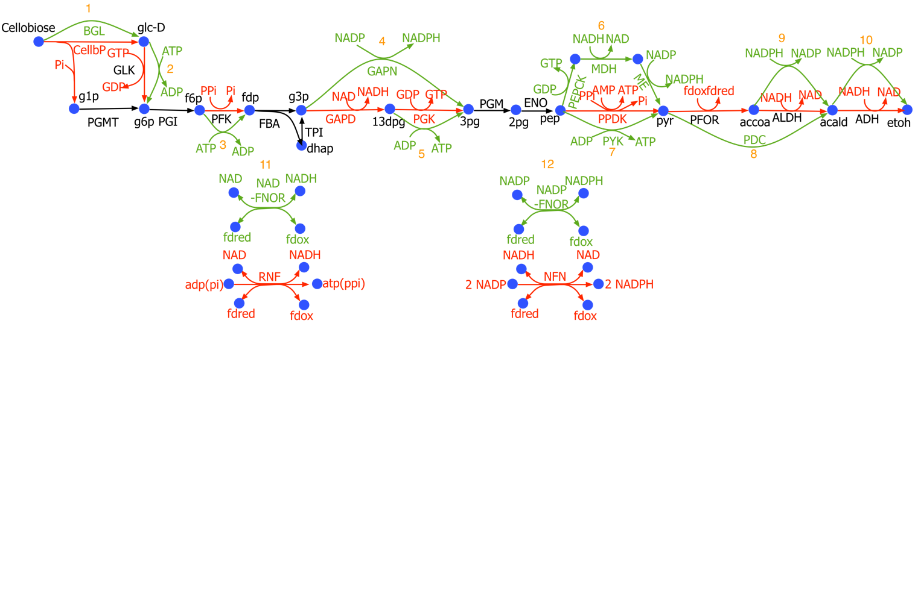

**Figure 1:** Glycolysis with ethanol production pathway in C. thermocellum: Reactions and cofactors shown in black are present in all cases. Reactions in red are replacement candidates. Reactions in green are the reactions being replaced. Specifically 1) cellobiose phosphorylase (CELLBP) with betaglucosidase (BGL) 2) GTP/GDP with ATP/ADP as cofactors for glucokinase 3) PPi/Pi with ATP/ADP as cofactors for PFK, 4) glyceraldehyde dehydrogenase (GAPD) and phosphoglycerate kinase (PGK) with non-phosphorylating glyceraldehyde dehydrogenase (GAPN), 5) GTP/GDP with ATP/ADP as cofactors for phosphoglycerate kinase (PGK) , 6) PPDK with PEPCK and malate shunt, 7) PPDK with PYK, 8) pyruvate ferredoxin oxidoreductase (PFOR) and aldehyde dehydrogenase (ALDH) with pyruvate decarboxylase (PDC), 9) NADH/NAD+with NADPH/NADP+ as cofactors for aldehyde dehydrogenase, 10) NADH/NAD+ with NADPH/NADP+ as cofactors for alcohol dehydrogenase, 11) H+-translocating ferredoxin:NAD+ oxidoreductase (RNF) with ferredoxin:NAD+ oxidoreductase (NADH-FNOR), and 12) NADH-dependent reduced ferredoxin:NADP+ oxidoreductase (NFN)with ferredoxin:NADP+ oxidoreductase (NADPH-FNOR) .

**Table 3.** Reaction in Wild-type *C. thermocellum* and the corresponding replacements

|  |  |  |  |
| --- | --- | --- | --- |
| Wild-type | | Replaced with | |
| Reaction name | Equation | Reaction name | Equation |
| CBP | pi + cellb <=> glc-d + g1p | BGL | cellb + h2o <=>2 glc-d |
| GLK-GTP | glc-d + gtp <=> g6p + gdp | GLK-ATP | glc-d + atp <=> g6p + adp |
| PFK-PPi | ppi + f6p <=> pi + fdp + h | PFK-ATP | atp + f6p <=> adp + fdp |
| GAPDH | pi + nad+ + g3p <=> nadh + 13dpg | GAPN | g3p + nadp+ + h2o <=> 3pg + nadph |
| PGK-GTP | gdp + 13dpg <=> gtp + 3pg |
| PGK-GTP | gdp + 13dpg <=> gtp + 3pg | PGK-ATP | adp + 13dpg <=> atp + 3pg |
| PPDK | amp + ppi + pep <=> atp + pi + pyr + h | PYK | adp + pep <=> pyr + atp |
| PPDK | amp + ppi + pep <=> atp + pi + pyr + h | PEPCK | gdp + co2 + pep <=> gtp + oaa |
| MDH | nadh + oaa <=> nad+ + mal-l |
| ME | nadp + mal-l <=> nadph + co2 + pyr |
| PFOR | coa + 2 fdxox + pyr <=> h + accoa + 2 fdxrd + co2 | PDC | pyr <=> acald + co2 |
| ALDH-NADH | nadh + accoa <=> nad+ + coa + acald |
| ALDH-NADH | nadh + accoa <=> nad+ + coa + acald | ALDH-NADPH | nadph + accoa <=> nadp+ + coa + acald |
| ADH-NADH | acald + nadh <=> etoh + nad+ | ADH-NADPH | acald + nadph <=> etoh + nadp+ |
| RNF_ATPase | 2 fdxrd + 1 nad+ + 0.25 adp + 0.25 pi <=> 2 fdxox + 1 nadh + 0.25 atp + 0.25 h2o | NADH-FNOR | 2 fdxrd + nad+ <=> 2 fdxox + nadh |
| RNF_PPiase | 2 fdxrd + 1 nad+ + 1 h + 1 pi <=> 2 fdxox + 1 nadh + 0.5 ppi + 0.5 h2o |
| NFN | 2 fdxrd + nadh + 2 nadp+ <=> 2 fdxox + nad+ + 2 nadph | NADPH-FNOR | fdxrd + nadp+ <=> 2 fdxox + nadph |

## Assessment of the thermodynamic consistency of the measured metabolite concentrations

In a previous study, the addition of ethanol was shown to inhibit *C. thermocellum* metabolism at the GAPDH reaction (Tian et al., 2017b). It was suggested that the inhibition was due to regulatory behavior, but an alternative hypothesis is that the inhibition may be due to one or more reactions reaching thermodynamic equilibrium. To test this hypothesis, we re-analyzed the relative concentration data from Tian et al using the MDF algorithm (Noor et al., 2014). The dataset includes intracellular metabolites collected from wild type (WT) *C. thermocellum* growing with and without (control) added ethanol for two replicates each at three different time points. The absolute concentrations at the different time points were evaluated using a reference dataset (see Table 1) of intracellular metabolite concentrations measured for the wild type (WT) *C. thermocellum* grown without any added ethanol. The ethanol concentration is steadily increased to reach a maximum concentration (i.e. at the final time point) of 40 g/L, at which point growth is completely inhibited. The depletion of extracellular cellobiose pool and increase in fermentation products (such as lactate, acetate, ethanol) (see Supplementary file 5), confirms that cellobiose is converted to ethanol during all three time points for the no-ethanol control but only for the first two time points upon ethanol addition implying thermodynamic feasibility of the ethanol production pathway for at least time points 1 and 2. However, under added ethanol the cellobiose consumption is reduced (time points 1, 2) with no cellobiose consumption beyond time point 3.

We first explored if the measured metabolite concentrations are thermodynamically feasible (i.e. allow for a positive MDF value) for all 3 time points of the no-ethanol control and for the first 2 time points of the added-ethanol study. In the absence of measurement, metabolite concentrations were allowed to vary within an assumed physiological range (1 μM - 20 mM), energy cofactor ratios (ATP/ADP, GTP/GDP, and PPi/Pi) were constrained to greater than 10:1 and redox cofactor ratios (NADH/NAD+, NADPH/NADP+, Fd(red)/Fd(ox)) were allowed to vary between 1:100 and 100:1 based on observations in *E. coli* and other clostridia when the carbon substrate is not limiting (Bennett and San, 2009; Meyer and Papoutsakis, 1989; Milo et al., 2010; Noor et al., 2014). Known concentrations were allowed to vary only within 20% of their measured values (one at a time) to account for possible measurement error. Calculation of the pathway MDF (positive MDF implies thermodynamic feasibility) indicated that the measurements for 3pg lead to negative MDF (with measured metabolites constrained by known values and others varying within physiologically meaningful concentrations (Noor et al., 2014)) for the ethanol-added samples implying error in quantitation (see Supplementary file 6). In the ethanol-added samples, the 3pg levels are at around 2.2 mM, however values would need to be about 40% lower (1.3 mM) to ensure thermodynamic feasibility. Although resolving this discrepancy is not the main point of this work, we recognize that this is an important task for future metabolomic studies in *C. thermocellum*. Measured values for 3pg were not considered in the subsequent analyses.

## Glycolysis in *C. thermocellum*

The reduced metabolomic dataset (i.e. ethanol, dhap, fdp accoa, coa, f6p, g6p, glc-d, pep, and mal-l) as described in the previous section were imposed as constraints to evaluate the wild-type *C. thermocellum* pathway MDF at all the time points in presence and absence of externally added ethanol as shown in Table 4. The analysis shows that the pathway MDF is constrained by cofactor pools (i.e., ATP/ADP and NADH/NAD ratios) but the overall ethanol production pathway is feasible for all cases except for the final time point upon ethanol addition. For the final time point, the increase in ethanol concentration lowers the driving force of the ADH reaction and leads to NADH accumulation. This lowers the driving force of NADH-generating GAPDH reaction due to product (i.e., NADH) accumulation and causes accumulation of upper glycolysis metabolites especially sugar phosphates such as dhap and f6p (also observed in ethanol stress studies (Tian et al., 2017b; Yang et al., 2012)) (Figure 2). The accumulated metabolite pools constrain generating reactions (PFK, FBA, GAPDH, ALDH and ADH) and consequently render them thermodynamic bottlenecks. Thus, we observe that the thermodynamic bottleneck is distributed across multiple reactions rather than a single one. This may allude to that there are no remaining ways to re-allocate concentrations so as to relieve thermodynamic barriers as many reactions have become at the same time limiting. Additional metabolite measurements, especially quantification of cofactor pool variation due to ethanol addition may help improve the precision of our thermodynamic bottleneck predictions.

**Table 4.** Pathway MDF in kJ/mol of wild-type *C. thermocellum* for all samples and time points with and without added ethanol. Negative MDF values indicate thermodynamic infeasibility at the final timepoints of ethanol addition

|  |  |  |
| --- | --- | --- |
| Time point (hr) | Externally added ethanol | No added ethanol |
| 2.00 | 0.33 | 0.46 |
| 3.85 | 0.27 | 0.30 |
| 5.90 | -0.01 | 0.34 |

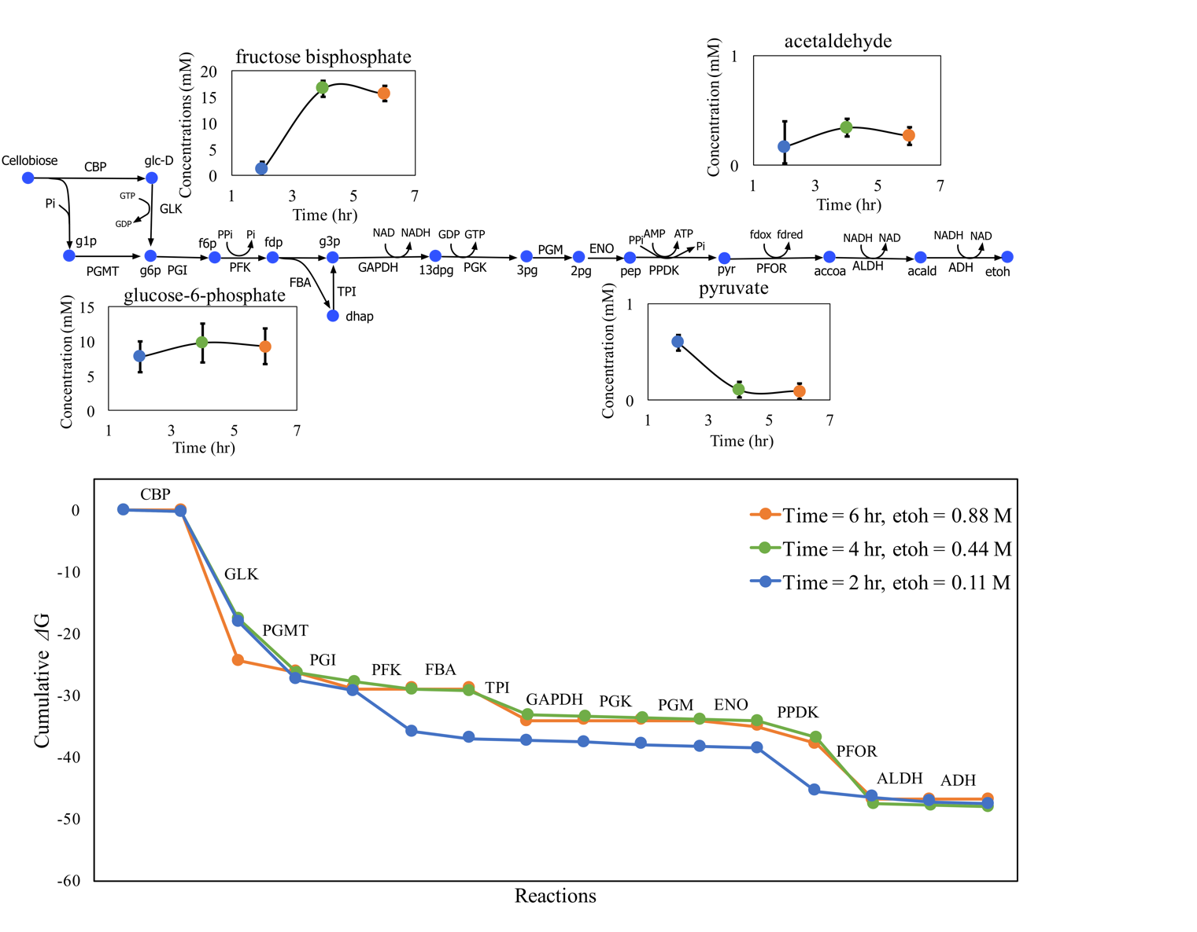

**Figure 2:** Glycolysis with ethanol production pathway in wild-type C. thermocellum with PPDK showing the thermodynamic analysis predicted variation in metabolite concentrations of key metabolites across time points. The external ethanol concentration increases along the time points. Sugar phosphates (e.g. fbp) in upper glycolysis accumulate upon ethanol addition. The bottom panel shows the thermodynamic profile of the ethanol production pathway for the three different time points shown as change in Gibbs free energy of the reactions. The thermodynamic infeasibility for the final time point is a consequence of the positive slope of PFK, FBA, GAPDH, ALDH, and ADH reactions.

## Ethanol pathway modification to relieve thermodynamic barriers

Thermodynamic analysis of WT *C. thermocellum* suggested that the variation in cofactor pool ratios (especially NADH/NAD+) plays an important role in the thermodynamic feasibility of ethanol production in *C. thermocellum*. Thus, perturbation in cofactor pools emerged as a primary target for increasing the pathway MDF. To this end, we explored the effect of modifying the cofactor association of a single or multiple reactions in *C. thermocellum* on the pathway MDF. We considered three alternatives to the native reactions (such as ATP linked glucokinase (GLK-ATP), ATP linked phosphoglycerate kinase (PGK-ATP), and malate shunt) and nine heterologous reactions: beta-glucosidase (BGL), ATP-linked phosphofructokinase (ATP-PFK), NADP-dependent glyceraldehyde 3-phosphate dehydrogenase (GAPN), pyruvate decarboxylase (PDC), NADPH-linked ALDH (ALDH-NADPH), NADPH-linked ADH (ADH-NADPH), ferredoxin:NAD+ oxidoreductase (NADH-FNOR), and ferredoxin:NADP+ oxidoreductase (NADPH-FNOR) (see Figure 1 and Table 3). A change in the reaction’s cofactor preference often implies changes in the corresponding cofactor availability. For example, changing the cofactor preference of the ADH reaction from NADH to NADPH requires that another step in the pathway must regenerate NADPH to ensure cofactor balance. We used the concept of elementary flux modes (EFMs) to formally capture all redox balanced combinations of reactions that allow conversion of one molecule of cellobiose into four molecules of ethanol while distinguishing between reactions that carry out the same conversion but rely on different cofactors. For each one of the identified 336 EFMs (Supplementary file 4) we calculated the ATP generated, the pathway MDF (at 1M ethanol) and the number of reaction modifications (i.e., cofactor swap) or additions/deletions. Figure 3 depicts the calculated MDF values, ATP generation, and number of modifications of all the EFMs with respect to WT.

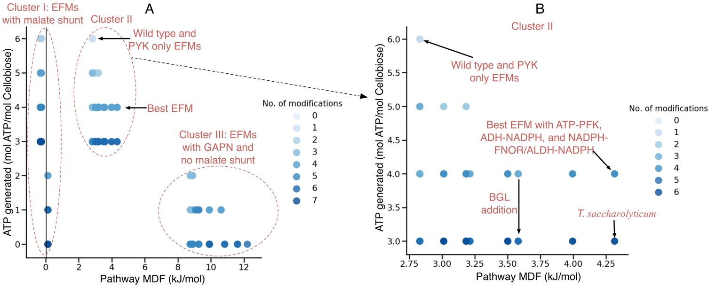

Figure 3: A) MDF at 1M ethanol concentration, ATP generated, and number of modifications in all 336 EFMs with three distinct Clusters I: EFMs with malate shunt, II: wild-type EFMs, Best EFMs with high MDF and ATP generation, and III: EFMs with GAPN and no malate shunt. B) Cluster II showing WT C. thermocellum, ethanologen T. saccharolyticum, and the best EFM with only ATP-PFK, ADH-NADPH and NADPH-FNOR/ALDH-NADPH to support NADPH generation. The EFMs are generated using all possible combinations of cofactor modifications as listed in Table 3. The shade of blue denotes the number of modifications in any EFM from the wild-type EFM.

Three distinct clusters of EFMs emerged upon plotting pathway MDF vs. ATP generated as seen in Figure 3. Cluster I: EFMs with malate shunt and low MDF (<1 kJ/mol), Cluster II: EFMs with intermediate MDF (3-5 kJ/mol) but high ATP generation (>2 mol ATP/ mol cellobiose), and Cluster III: EFMs with GAPN and high MDF (>8 kJ/mol) but low ATP generation (<3 mol ATP/ mol cellobiose).

## Cluster I (malate shunt)

All of the EFMs in Cluster I contain the malate shunt (i.e. phosphoenolpyruvate is converted to pyruvate via oxaloacetate and malate) and are either thermodynamically infeasible (i.e. negative MDF) or have an MDF value slightly greater than zero (i.e., 0.13 kJ/mol) for cases with GAPN (the impact of GAPN is more prominent in Cluster III as discussed in the latter section). *C. thermocellum* does not possess the conventional pyruvate kinase (PYK) enzyme, instead it uses either pyruvate phosphate dikinase (PPDK) or the malate shunt (phosphoenolpyruvate carboxykinase (PEPCK), malate dehydrogenase (MDH), and malic enzyme (ME)) to convert phosphoenolpyruvate to pyruvate (see Figure 1). The EFMs in Cluster I show that PPDK (WT-EFM) is more thermodynamically favorable than its counterpart malate shunt. It is known that malate shunt functions *in vivo* in *C. thermocellum* (Olson et al., 2017), and it is thought that the purpose of the pathway is to supply reduced NADPH for anabolism. However, the thermodynamic feasibility of the PEPCK reaction is limited by intracellular CO2 and oxaloacetate (oaa) concentrations. For our MDF analysis, we fixed the CO2 concentration at 10 µM (> 30 µM required for PEPCK feasibility) which corresponds to the equilibrium concentration at standard atmospheric condition of 400ppm CO2(g). A higher intracellular CO2 concentration (i.e., > 40,000 µM) is required to remove limitations on the ΔrG′ of the PEPCK reaction alluding to supersaturation of CO2 in the media during fermentation as observed by Blunt et al (Blunt et al., 2015). Since CO2 concentration also depends on pH, an intracellular pH > 7 would allow for higher levels of CO2 than what we have assumed. The intracellular pH of *C. thermocellum* is not known. The sensitivity of the PEPCK reaction to the CO2 concentration (Supplementary file 7) may explain why *C. thermocellum* grows much better in the presence of CO2, whether enriched in the atmosphere (typically at 10% v/v) or added as bicarbonate in the growth medium (Xiong et al., 2017). An alternate driver of PEPCK thermodynamic feasibility is depletion of the oxaloacetate (oaa) pool (< 0.3 µM) due to its spontaneous decarboxylation which also impacts oaa detection in *C. thermocellum* (Zhou et al., 2013). The challenges in CO2 and oaa measurements can be circumvented indirectly by experimentally measuring other reactants and products in the malate shunt pathway to inform us of *C. thermocellum’s* ethanol production pathway thermodynamics.

## Cluster II

The most highly varied pathway modifications belong to Cluster II. They all retain ATP generation and also significantly increase pathway MDF as shown in Figure 3B. We observe that the presence of pyruvate kinase (PYK) in an EFM does not affect the MDF or the ATP generated by the pathway. On the other hand, betaglucosidase (BGL) addition (by replacing cellobiose phosphorylase) reduces the ATP generation by 1 mol ATP/mol cellobiose (see Figure 3B) but keeps MDF unchanged. The best EFM (i.e., highest MDF with largest ATP generation) in Cluster II involves three modifications: PFK-ATP, ADH-NADPH, and ALDH-NADPH/NADPH-FNOR (Supplementary file 4) with an MDF of 4.3 kJ/mol and 4 moles of generated ATP. The inclusion of ATP-PFK leads to a higher MDF at the expense of ATP generation (the native PFK consumes PPi which is equivalent to 0.5 ATP (Zhou et al., 2013)) while the NADPH linked ADH reaction decouples the impact of ethanol concentrations on NADH associated reactions. ALDH-NADPH or NADPH-FNOR reaction is required to account for NADPH generation and ensure redox balance (Figure 3B). It is interesting to note here that studies have also shown that the cofactor specificity of alcohol dehydrogenase changes to NADPH from NADH in high ethanol yielding strains of *C. thermocellum* (Zheng et al., 2015). We also observe that EFM-46 (see Supplementary file 4 and Figure 3B) corresponds to the glycolysis and fermentation pathways in a strain of *T. saccharolyticum* engineered for homo-ethanol fermentation with high ethanol yields and titers (Herring et al., 2016). The *T. saccharolyticum* cellobiose to ethanol pathway has seven differences compared to WT *C. thermocellum* cellobiose to ethanol pathway (see Figure 4), however only three genetic interventions (ATP-PFK, NADPH-ADH and either NADPH-ALDH or NADPH-FNOR) to WT *C. thermocellum* are sufficient to maintain high MDF and high ATP theoretical yield without having to fully convert glycolysis to that of *T. saccharolyticum* ethanologen. Of course, thermodynamic feasibility and high ATP yield are necessary but not sufficient conditions for high ethanol titers. Additional bottlenecks may lie with enzyme kinetics and/or pathway regulation.

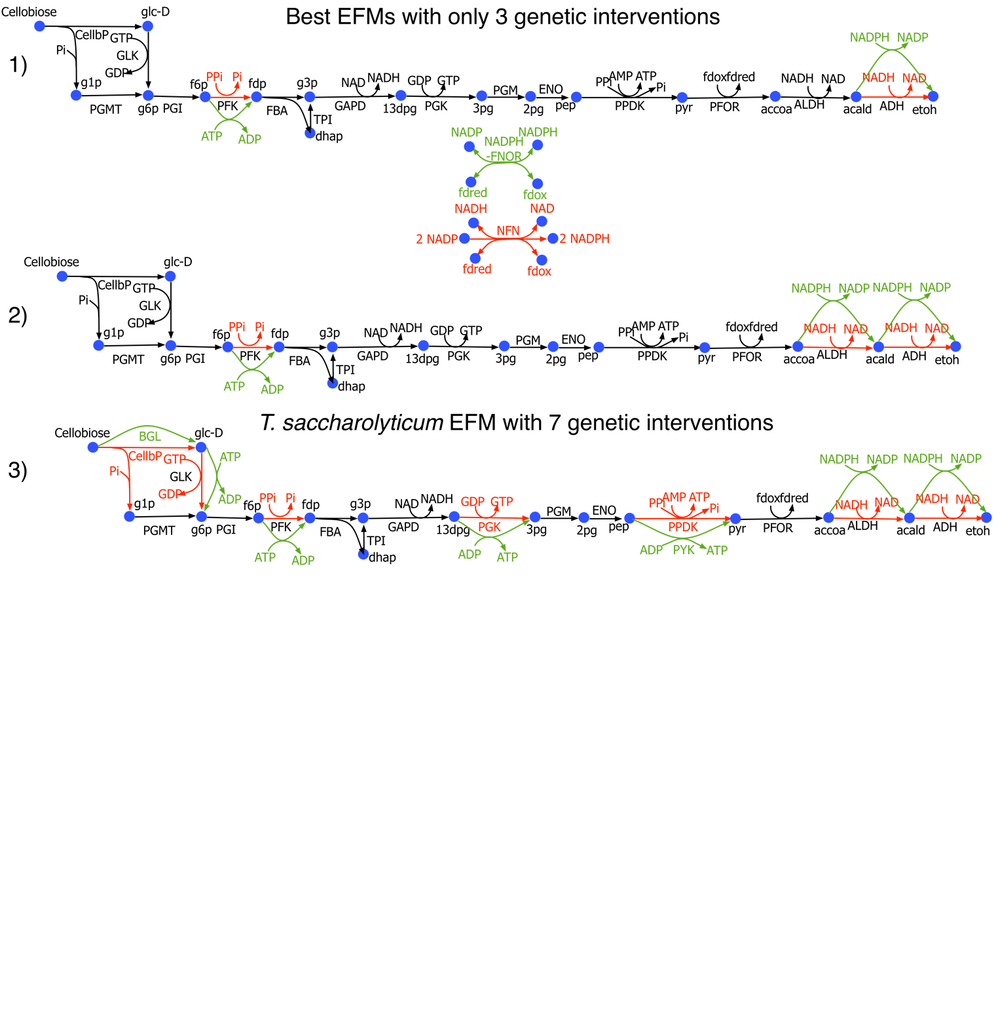

Figure 4: Metabolic pathway map for the best EFMs in Cluster II with only three genetic interventions compared to the EFM which corresponds to T. saccharolyticum: 1) The best EFM with ATP-PFK, ADH-NADPH and NADPH-FNOR, 2) The best EFM with ATP-PFK, ADH-NADPH and ALDH-NADPH. 3) T. saccharolyticum EFM with BGL, ATP- PFK, ATP-PGK, PYK, ALDH-NADPH, and ADH-NADPH. All the EFMs here have an MDF of 4.32 kJ/ mol, but the best EFMs generate 4 mol ATP/mol cellobiose compared to 3 mol ATP/mol cellobiose by T. saccharolyticum EFM.

## 3.2.3. Cluster III (GAPN without malate shunt)

All the EFMs in Cluster III involve the GAPN reaction which replaces GAPDH and PGK reactions from wild-type *C. thermocellum*. Previous studies have shown that this intervention can improve ethanol yield in yeast and lysine yield in *Corynebacterium glutamicum* (Guo et al., 2011; Takeno et al., 2016). GAPN mitigates the thermodynamic barrier posed by GAPDH as highlighted in the earlier sections due to rising NADH concentrations by changing the cofactor dependency to NAPDH and reducing ATP generation, which however is necessary for cell growth. The EFM with the highest MDF in Cluster III completely removes NADH association with the ethanol production by relying on PDC and NADPH linked ADH. PDC replaces PFOR and ALDH-NADH thus eliminating electron transfer from reduced ferredoxin to NADP or NAD. High GTP/ATP and reduced-ferredoxin pools in *C. thermocellum* negatively impact pathway MDF via PGK and PFOR respectively due to higher product concentration. Thus, inclusion of GAPN and PDC increases pathway MDF. It is also interesting to note that studies have shown a higher NADPH/NADP+ ratio compared to NADH/NAD+ ratio in *C. thermocellum* and thus NADPH linked reactions would tend to have a higher MDF in engineered strains (Beri et al., 2016). Implementing a pathway with both GAPN and PDC (EFM-8) in *C. thermocellum* would eliminate thermodynamic equilibrium as a limitation to high titer ethanol production. It would also reduce ATP generation to 1 (at most) mol ATP/mol cellobiose. Although some organisms, such as *Zymomonas mobilis*, are able to survive with such a low ATP yield (Rutkis et al., 2016), *C. thermocellum* might have difficulty synthesizing its cellulosome. Therefore, these interventions could be useful in cases where product formation is decoupled from cell growth (Holwerda et al., 2014).

1. **Conclusions**

This study analyzes wild-type *C. thermocellum* glycolysis using metabolomic datasets to understand the impact of increasing ethanol concentration on pathway thermodynamics. Sugar phosphates and NADH pool accumulation at high ethanol concentrations renders ethanol production thermodynamically infeasible by disallowing a positive MDF for five reactions (PFK, FBA, GAPDH, ALDH and ADH). Plausible pathway modifications were explored and described using the EFM concept. Results revealed the thermodynamic disadvantage of the malate shunt (over PPDK) under physiological CO2 concentrations and the benefit of introducing the GAPN reaction (instead of GAPDH and PGK). GAPN increases the MDF and resolves the GAPDH bottleneck but at the expense of reduced ATP generation at high ethanol concentrations. The study identified the combination of ATP linked PFK and NADPH linked ADH with NADPH linked ALDH or NADPH-FNOR reactions as the best set of genetic interventions which retains ATP generation while maintaining a high MDF similar to the thermophilic ethanologen *T. saccharolyticum*. It must be emphasized that this analysis is based on a partial list of measured pathway metabolites and increasing the number of measured metabolites (particularly cofactors, which participate in many reactions), determining the problems with 3pg quantification, and improving the quantification accuracy (which would allow reducing the error factor below the current value of 20%) will further improve our understanding of the thermodynamic landscape.

It is also important to highlight some of the assumptions and limitations of the MDF analysis carried out in this study. The thermodynamics of cellulose degradation was not considered here due to the heterogeneity of possible products, presence of both intra- and extra-cellular steps and uncertainties on free energy values (Lynd, 2017; Lynd et al., 2017). Instead the analysis was carried out with intracellular cellobiose as the starting point. Other pathways which produce acetate and amino acids that may interact with the ethanol producing pathway through the cofactor pools were also not considered in the analysis. This was because ethanol is the target product of our study and competing products are generally eliminated or have minimal yield under high ethanol yielding strains (Olson et al., 2017; Olson et al., 2015). This study also uses a small set of measurement metabolite pools as constraints, thus lack of intermediate metabolite measurements would lead to unconstrained metabolite pools and render any additional pathway always thermodynamically feasible. We also observed that addition of acetate production pathway did not change the results predicted in this study due to lack of acutely-coa and acetaldehyde measurements. Furthermore, we assumed that the intracellular concentration of ethanol to be the same as the extracellular concentration, since the cytoplasmic membrane is not a significant barrier to ethanol diffusion (Shinoda, 2016). However, this assumption may not hold true for other potential biofuel molecules such as butanol warranting intracellular measurements for accurate quantification of MDF.

Most organisms that produce ethanol at high titer use a pathway for converting pyruvate to ethanol that involves the pyruvate decarboxylase reaction. There are only one or two examples of organisms that can produce ethanol at high titer using the pyruvate ferredoxin oxidoreductase pathway. With so few examples, it’s hard to draw general conclusions (Olson et al., 2015).

Despite all these simplifications, results obtained demonstrate that MDF analysis is an important first step for assessing thermodynamic feasibility of a pathway and for proposing modifications. Organisms that produce high ethanol titers vary in terms of the reactions employed in their ethanol production pathway. While the MDF analysis shows that specific genetic combinations outperform others, there are however multiple genetic combinations which can resolve the thermodynamic infeasibility problem. Thus, additional criteria such as enzyme-host compatibility (Amin et al., 2019), enzyme thermostability, cofactor availability (Uppada et al., 2017) can be considered. Of course, thermodynamic feasibility does not necessarily imply metabolic feasibility as both kinetics and regulation must be sufficient to maintain the required metabolic flows. Follow up investigations of the pathways for their enzyme kinetics and possible regulations are likely to be important (Dash et al., 2017; Rydzak et al., 2012) but they will still have to operate within the confines defined by thermodynamics.

**Funding**

This work was supported by the Center for Bioenergy Innovation. The Center for Bioenergy Innovation is a U.S. Department of Energy Bioenergy Research Center supported by the Office of Biological and Environmental Research in the DOE Office of Science.

**Competing interests**

Lee R. Lynd is a founder of the Enchi Corporation, which has a financial interest in *Clostridium thermocellum*.

**References**

Amin, S. A., Endalur Gopinarayanan, V., Nair, N. U., Hassoun, S., 2019. Establishing synthesis pathway-host compatibility via enzyme solubility. Biotechnology and bioengineering. 116**,** 1405-1416.

Ataman, M., Hatzimanikatis, V., 2015. Heading in the right direction: thermodynamics-based network analysis and pathway engineering. Curr Opin Biotechnol. 36**,** 176-82.

Bennett, G. N., San, K. Y., 2009. Engineering E. coli Central Metabolism for Enhanced Primary Metabolite Production. Systems Biology and Biotechnology of Escherichia Coli. 351-376.

Beri, D., Olson, D. G., Holwerda, E. K., Lynd, L. R., 2016. Nicotinamide cofactor ratios in engineered strains of Clostridium thermocellum and Thermoanaerobacterium saccharolyticum. Fems Microbiol Lett. 363.

Blunt, W. A., Gapes, D. J., Sparling, R., Levin, D. B., Cicek, N., Quantitative assessment of H2 and CO2 supersaturation during thermophilic cellobiose fermentation with Clostridium thermocellum. 2015 ASABE Annual International Meeting. American Society of Agricultural and Biological Engineers, 2015, pp. 1.

Brown, S. D., Guss, A. M., Karpinets, T. V., Parks, J. M., Smolin, N., Yang, S. H., Land, M. L., Klingeman, D. M., Bhandiwad, A., Rodriguez, M., Raman, B., Shao, X. J., Mielenz, J. R., Smith, J. C., Keller, M., Lynd, L. R., 2011. Mutant alcohol dehydrogenase leads to improved ethanol tolerance in Clostridium thermocellum. P Natl Acad Sci USA. 108**,** 13752-13757.

Dash, S., Khodayari, A., Zhou, J., Holwerda, E. K., Olson, D. G., Lynd, L. R., Maranas, C. D., 2017. Development of a core Clostridium thermocellum kinetic metabolic model consistent with multiple genetic perturbations. Biotechnol Biofuels. 10**,** 108.

de Figueiredo, L. F., Podhorski, A., Rubio, A., Kaleta, C., Beasley, J. E., Schuster, S., Planes, F. J., 2009. Computing the shortest elementary flux modes in genome-scale metabolic networks. Bioinformatics. 25**,** 3158-3165.

Demain, A. L., Newcomb, M., Wu, J. H., 2005. Cellulase, clostridia, and ethanol. Microbiol Mol Biol Rev. 69**,** 124-54.

Guo, Z. P., Zhang, L., Ding, Z. Y., Wang, Z. X., Shi, G. Y., 2011. Improving ethanol productivity by modification of glycolytic redox factor generation in glycerol-3-phosphate dehydrogenase mutants of an industrial ethanol yeast. J Ind Microbiol Biotechnol. 38**,** 935-43.

Hadicke, O., von Kamp, A., Aydogan, T., Klamt, S., 2018. OptMDFpathway: Identification of metabolic pathways with maximal thermodynamic driving force and its application for analyzing the endogenous CO2 fixation potential of Escherichia coli. Plos Computational Biology. 14.

Herring, C. D., Kenealy, W. R., Shaw, A. J., Covalla, S. F., Olson, D. G., Zhang, J. Y., Sillers, W. R., Tsakraklides, V., Bardsley, J. S., Rogers, S. R., Thorne, P. G., Johnson, J. P., Foster, A., Shikhare, I. D., Klingeman, D. M., Brown, S. D., Davison, B. H., Lynd, L. R., Hogsett, D. A., 2016. Strain and bioprocess improvement of a thermophilic anaerobe for the production of ethanol from wood. Biotechnol Biofuels. 9.

Holwerda, E. K., Thorne, P. G., Olson, D. G., Amador-Noguez, D., Engle, N. L., Tschaplinski, T. J., van Dijken, J. P., Lynd, L. R., 2014. The exometabolome of Clostridium thermocellum reveals overflow metabolism at high cellulose loading. Biotechnol Biofuels. 7**,** 155.

Hon, S., Olson, D. G., Holwerda, E. K., Lanahan, A. A., Murphy, S. J. L., Maloney, M. I., Zheng, T., Papanek, B., Guss, A. M., Lynd, L. R., 2017. The ethanol pathway from Thermoanaerobacterium saccharolyticum improves ethanol production in Clostridium thermocellum. Metab Eng. 42**,** 175-184.

Lynd, L. R., 2017. The grand challenge of cellulosic biofuels. Nat Biotechnol. 35**,** 912-915.

Lynd, L. R., Liang, X. Y., Biddy, M. J., Allee, A., Cai, H., Foust, T., Himmel, M. E., Laser, M. S., Wang, M., Wyman, C. E., 2017. Cellulosic ethanol: status and innovation. Curr Opin Biotech. 45**,** 202-211.

Lynd, L. R., Weimer, P. J., van Zyl, W. H., Pretorius, I. S., 2002. Microbial cellulose utilization: fundamentals and biotechnology. Microbiol Mol Biol Rev. 66**,** 506-77, table of contents.

Meyer, C. L., Papoutsakis, E. T., 1989. Increased Levels of Atp and Nadh Are Associated with Increased Solvent Production in Continuous Cultures of Clostridium-Acetobutylicum. Appl Microbiol Biotechnol. 30**,** 450-459.

Milo, R., Jorgensen, P., Moran, U., Weber, G., Springer, M., 2010. BioNumbers--the database of key numbers in molecular and cell biology. Nucleic Acids Res. 38**,** D750-3.

Noor, E., Bar-Even, A., Flamholz, A., Reznik, E., Liebermeister, W., Milo, R., 2014. Pathway thermodynamics highlights kinetic obstacles in central metabolism. PLoS Comput Biol. 10**,** e1003483.

Noor, E., Haraldsdottir, H. S., Milo, R., Fleming, R. M., 2013. Consistent estimation of Gibbs energy using component contributions. PLoS Comput Biol. 9**,** e1003098.

Olson, D. G., Horl, M., Fuhrer, T., Cui, J., Zhou, J., Maloney, M. I., Amador-Noguez, D., Tian, L., Sauer, U., Lynd, L. R., 2017. Glycolysis without pyruvate kinase in Clostridium thermocellum. Metab Eng. 39**,** 169-180.

Olson, D. G., McBride, J. E., Shaw, A. J., Lynd, L. R., 2012. Recent progress in consolidated bioprocessing. Curr Opin Biotech. 23**,** 396-405.

Olson, D. G., Sparling, R., Lynd, L. R., 2015. Ethanol production by engineered thermophiles. Curr Opin Biotechnol. 33**,** 130-41.

Peres, S., Jolicœur, M., Moulin, C., Dague, P., Schuster, S., 2017. How important is thermodynamics for identifying elementary flux modes? PLoS One. 12**,** e0171440.

Pharkya, P., Burgard, A. P., Maranas, C. D., 2004. OptStrain: A computational framework for redesign of microbial production systems. Genome Research. 14**,** 2367-2376.

Rabinowitz, J. D., Kimball, E., 2007. Acidic acetonitrile for cellular metabolome extraction from Escherichia coli. Analytical Chemistry. 79**,** 6167-6173.

Rutkis, R., Strazdina, I., Balodite, E., Lasa, Z., Galinina, N., Kalnenieks, U., 2016. The Low Energy-Coupling Respiration in Zymomonas mobilis Accelerates Flux in the Entner-Doudoroff Pathway. Plos One. 11.

Rydzak, T., McQueen, P. D., Krokhin, O. V., Spicer, V., Ezzati, P., Dwivedi, R. C., Shamshurin, D., Levin, D. B., Wilkins, J. A., Sparling, R., 2012. Proteomic analysis of Clostridium thermocellum core metabolism: relative protein expression profiles and growth phase-dependent changes in protein expression. BMC Microbiol. 12**,** 214.

Shao, X. J., Raman, B., Zhu, M. J., Mielenz, J. R., Brown, S. D., Guss, A. M., Lynd, L. R., 2011. Mutant selection and phenotypic and genetic characterization of ethanol-tolerant strains of Clostridium thermocellum. Appl Microbiol Biot. 92**,** 641-652.

Shinoda, W., 2016. Permeability across lipid membranes. Bba-Biomembranes. 1858**,** 2254-2265.

Takeno, S., Hori, K., Ohtani, S., Mimura, A., Mitsuhashi, S., Ikeda, M., 2016. L-Lysine production independent of the oxidative pentose phosphate pathway by Corynebacterium glutamicum with the Streptococcus mutans gapN gene. Metab Eng. 37**,** 1-10.

Thompson, R. A., Layton, D. S., Guss, A. M., Olson, D. G., Lynd, L. R., Trinh, C. T., 2015. Elucidating central metabolic redox obstacles hindering ethanol production in Clostridium thermocellum. Metab Eng. 32**,** 207-219.

Thompson, R. A., Trinh, C. T., 2017. Overflow metabolism and growth cessation in Clostridium thermocellum DSM1313 during high cellulose loading fermentations. Biotechnology and bioengineering. 114**,** 2592-2604.

Tian, L., Perot, S. J., Hon, S., Zhou, J., Liang, X., Bouvier, J. T., Guss, A. M., Olson, D. G., Lynd, L. R., 2017a. Enhanced ethanol formation by Clostridium thermocellum via pyruvate decarboxylase. Microb Cell Fact. 16**,** 171.

Tian, L., Perot, S. J., Stevenson, D., Jacobson, T., Lanahan, A. A., Amador-Noguez, D., Olson, D. G., Lynd, L. R., 2017b. Metabolome analysis reveals a role for glyceraldehyde 3-phosphate dehydrogenase in the inhibition of C. thermocellum by ethanol. Biotechnol Biofuels. 10**,** 276.

Trinh, C. T., Wlaschin, A., Srienc, F., 2009. Elementary mode analysis: a useful metabolic pathway analysis tool for characterizing cellular metabolism. Appl Microbiol Biotechnol. 81**,** 813-26.

Uppada, V., Satpute, K., Noronha, S., 2017. Redesigning cofactor availability: an essential requirement for metabolic engineering. Current Developments in Biotechnology and Bioengineering. Elsevier, pp. 223-242.

Volkmer, B., Heinemann, M., 2011. Condition-Dependent Cell Volume and Concentration of Escherichia coli to Facilitate Data Conversion for Systems Biology Modeling. Plos One. 6.

Wlaschin, A. P., Trinh, C. T., Carlson, R., Srienc, F., 2006. The fractional contributions of elementary modes to the metabolism of Escherichia coli and their estimation from reaction entropies. Metab Eng. 8**,** 338-52.

Xiong, W., Lin, P., Magnusson, L., Warner, L., Liao, J., Maness, P., Chou, K., 2017. Discovery of CO2-fixing one-carbon (C1) metabolism in a cellulose degrading bacterium Clostridium thermocellum. Abstr Pap Am Chem S. 253.

Yang, S., Giannone, R. J., Dice, L., Yang, Z. K., Engle, N. L., Tschaplinski, T. J., Hettich, R. L., Brown, S. D., 2012. Clostridium thermocellum ATCC27405 transcriptomic, metabolomic and proteomic profiles after ethanol stress. BMC Genomics. 13**,** 336.

Zheng, T. Y., Olson, D. G., Tian, L., Bomble, Y. J., Himmel, M. E., Lo, J., Hon, S., Shaw, A. J., van Dijken, J. P., Lynd, L. R., 2015. Cofactor Specificity of the Bifunctional Alcohol and Aldehyde Dehydrogenase (AdhE) in Wild-Type and Mutant Clostridium thermocellum and Thermoanaerobacterium saccharolyticum. Journal of Bacteriology. 197**,** 2610-2619.

Zhou, J., Olson, D. G., Argyros, D. A., Deng, Y., van Gulik, W. M., van Dijken, J. P., Lynd, L. R., 2013. Atypical glycolysis in Clostridium thermocellum. Appl Environ Microbiol. 79**,** 3000-8.